Deep Learning – Assignment 1

Aaron Williams

**Problem 1:**

a)

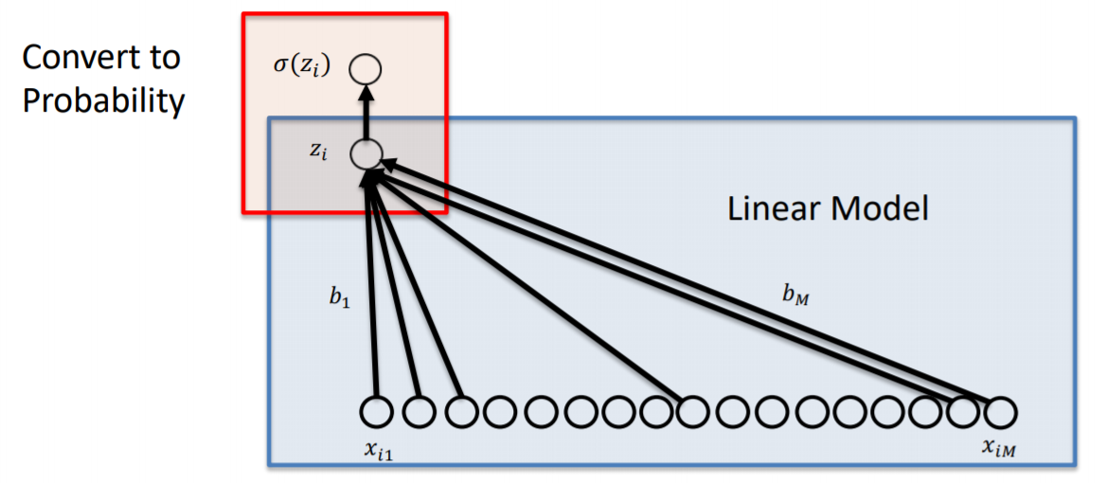

$$z=b_{0}+\sum_{n=1}^{M}{b_{n}x_{n}} or z=b_{0}+b·x where b and x are vectors of equal length$$

$$\hat{y}=σ\left(z\right)=\frac{1}{1+e^{-z}}$$

$$f\left(\hat{y}\right)={\left(y-\hat{y}\right)}^{2}$$

$$f\left(b\right)={\left(y-\frac{1}{1+e^{-(b_{0}+bx)}}\right)}^{2}$$

$$\frac{df}{db}=\frac{dz}{db}*\frac{d\hat{y}}{dz}*\frac{df}{d\hat{y}}=x*\frac{e^{-(b_{0}+bx)}}{{\left(e^{-(b_{0}+bx)}+1\right)}^{2}}*2\left(\frac{1}{1+e^{-(b_{0}+bx)}}-y\right)$$

b)

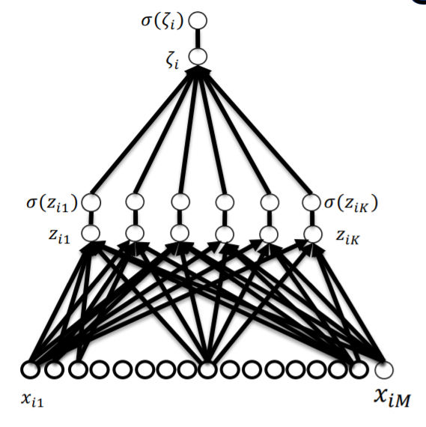

$$z=b_{0}+b·x and ζ=a_{0}+\sum_{n=1}^{K}{a_{n}σ_{n}\left(z\right)} or$$

$$ζ=a_{0}+a·σ\left(z\right) where 'a' represents our second layer weights$$

$$\hat{y}=\frac{1}{1+e^{-ζ}}$$

$$f\left(\hat{y}\right)={\left(y-\hat{y}\right)}^{2}$$

$$f\left(a\right)={\left(y-\frac{1}{1+e^{-(a_{0}+aσ\left(z\right))}}\right)}^{2}$$

$$σ\left(z\right)=\frac{1}{1+e^{-(b_{0}+bx)}}$$

$$\frac{df}{da}=\frac{d ζ}{da}*\frac{d\hat{y} }{dζ}*\frac{df}{d\hat{y}}=σ\left(z\right)*\frac{e^{-(a_{0}+aσ\left(z\right))}}{{\left(e^{-(a_{0}+aσ\left(z\right))}+1\right)}^{2}}*2\left(\frac{1}{1+e^{-(a_{0}+aσ\left(z\right))}}-y\right)$$

$$\frac{df}{db}=\frac{dz}{db}*\frac{da}{dz}*\frac{d ζ}{da}*\frac{d\hat{y} }{dζ}*\frac{df}{d\hat{y}}=x*\frac{e^{-(b_{0}+bx)}}{{\left(e^{-(b_{0}+bx)}+1\right)}^{2}}*\frac{1}{1+e^{-(b_{0}+bx)}}*\frac{e^{-ζ}}{{\left(e^{-ζ}+1\right)}^{2}}*2\left(\frac{1}{1+e^{-ζ}}-y\right)$$

$$where ζ=a_{0}+a·\frac{1}{1+e^{-(b_{0}+bx)}}$$

c)

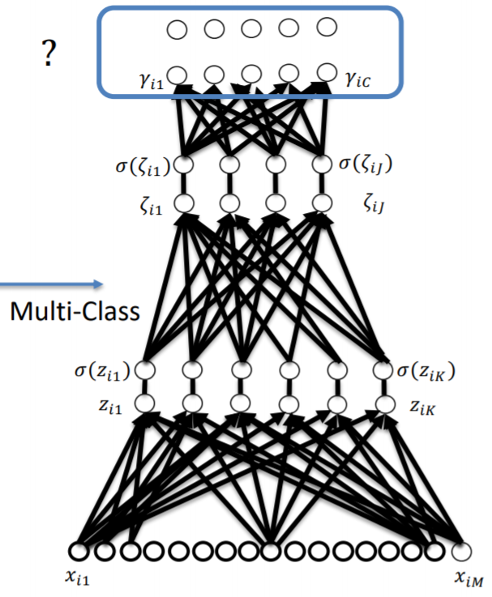

Considering we have some set of results from a multi-class system $σ\left(z_{c}\right)$ such that $z$ is a vector

$${\hat{y}}_{c}=\frac{e^{z_{c}}}{\sum_{n=1}^{C_{total}}{e^{z_{n}}}}$$

$$\frac{d\hat{y} }{dz}=\frac{(\sum_{n=1}^{C_{total}}{e^{z_{n}}}-e^{z_{c}})e^{z_{c}}}{{\left(\sum_{n=1}^{C_{total}}{e^{z_{n}}}\right)}^{2}}$$

$\frac{d\hat{y} }{dz}$ of the single layer and $\frac{d\hat{y} }{dζ}$ of the double layer would be replaced by the above backpropagation term. Additionally, each weighting term (such as ‘a’ or ‘b’) would become a matrix with an additional dimension of $C_{total}$ length. Here is the single layer problem with multi-class.

$$\frac{df}{db}=\frac{dz}{db}*\frac{d\hat{y}}{dz}*\frac{df}{d\hat{y}}=x*\frac{(\sum_{n=1}^{C_{total}}{e^{z_{n}}}-e^{z_{c}})e^{z_{c}}}{{\left(\sum_{n=1}^{C_{total}}{e^{z_{n}}}\right)}^{2}}*2\left(\frac{e^{z_{c}}}{\sum_{n=1}^{C_{total}}{e^{z_{n}}}}-y\right)$$

And for network with another layer,

$$\frac{df}{db}=\frac{dz}{db}*\frac{da}{dz}*\frac{d ζ}{da}*\frac{d\hat{y} }{dζ}*\frac{df}{d\hat{y}}=x*\frac{e^{-\left(b_{0}+bx\right)}}{{\left(e^{-\left(b_{0}+bx\right)}+1\right)}^{2}}*\frac{1}{1+e^{-\left(b_{0}+bx\right)}}*\frac{\left(\sum_{n=1}^{C_{total}}{e^{ζ_{n}}}-e^{ζ_{c}}\right)e^{ζ_{c}}}{{\left(\sum_{n=1}^{C_{total}}{e^{ζ_{n}}}\right)}^{2}}*2\left(\frac{e^{ζ_{c}}}{\sum_{n=1}^{C_{total}}{e^{ζ_{n}}}}-y\right)$$

$$where ζ=a_{0}+a·\frac{1}{1+e^{-(b_{0}+bx)}}$$

**Problem 5:**

a)

I have not yet run code on the cluster, but it will be my next priority on submission of this assignment. I may also try and use my own GPU, but it might be outdated depending on the computation power required.

b)

Problem 1: 3 hours

Problem 2: 4 hours

Problem 3: 4 hours (stuck 2.5 hours because I didn’t see I had to randomize my layer values :/)

Problem 4: 25 minutes

Problem 5: 5 minutes

Total: 11 hours and 30 minutes

c)

I adhered to the Duke Community Standard in the completion of this assignment.